# Summary of WIHR Director Candidate Survey Analysis

## 1. Introduction

We conducted an analysis of survey responses following the presentations of two candidates for the WIHR Director position. Survey participants rated the candidates across six key evaluation criteria.

## 2. Data Transformation: Conversion to Likert Scale (Overall analysis part)

The original survey responses (Column G to L) were provided as text responses such as 'Strongly agree,' 'Somewhat agree,' etc. To enable numerical analysis, these responses were converted to a standard 5-point Likert scale as follows:

|  |  |
| --- | --- |
| Response Text | Numeric Value |
| Strongly agree | 5 |
| Somewhat agree | 4 |
| Neither agree nor disagree | 3 |
| Somewhat disagree | 2 |
| Strongly disagree | 1 |

This transformation allowed calculation of medians and comparative analysis between candidates.

## 3. Breakdown by Collection Mode

Responses were collected through two methods: Meeting and Public link.

|  |  |  |
| --- | --- | --- |
| Collection Mode | Morris Responses | Sailor Responses |
| Meeting | 21 | 12 |
| Public link | 9 | 11 |

## 5. Visual Summaries

## Columns: G to L

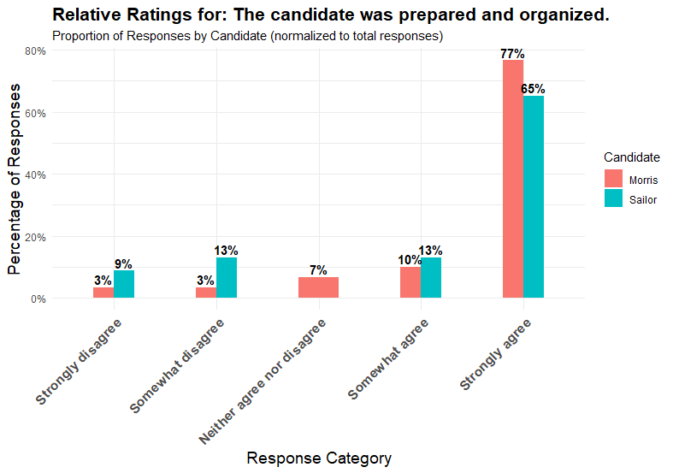

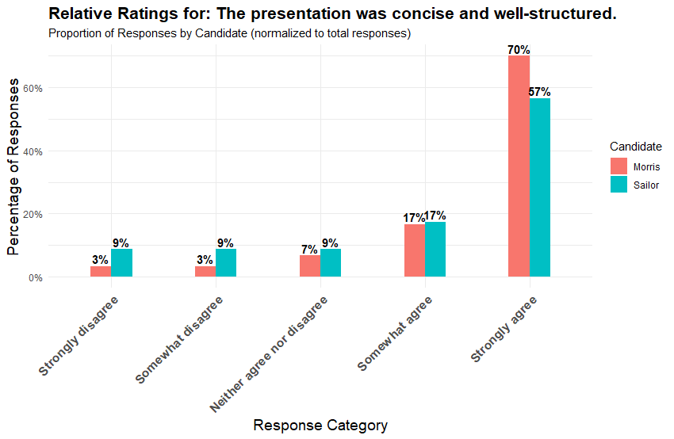

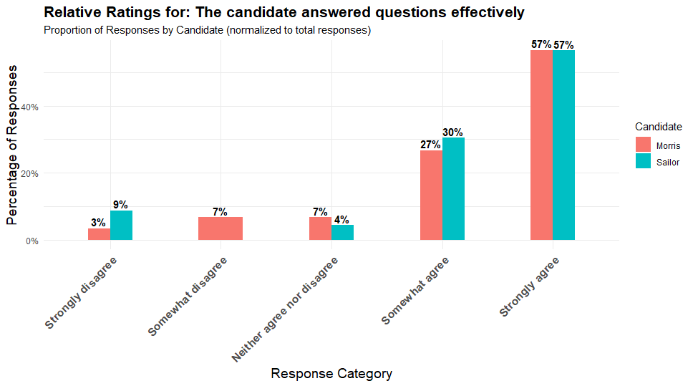

**Overall analysis (Columns G to L):**

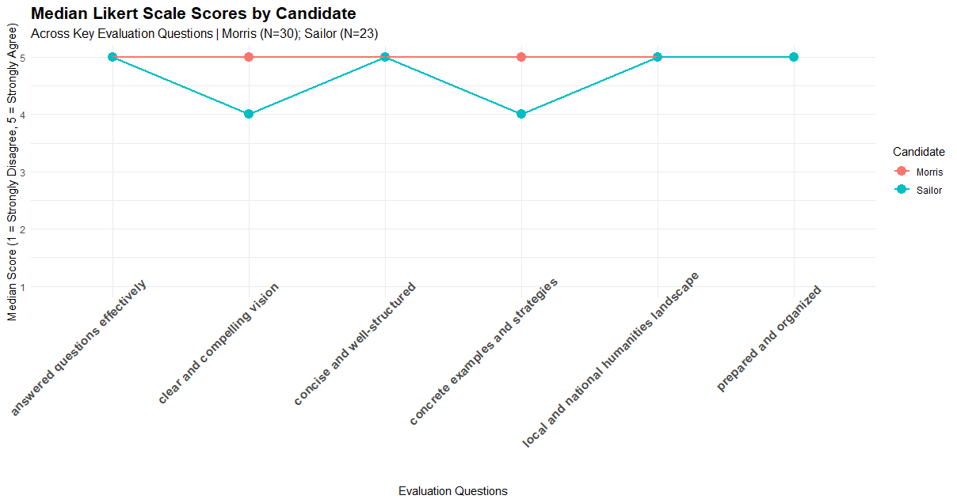

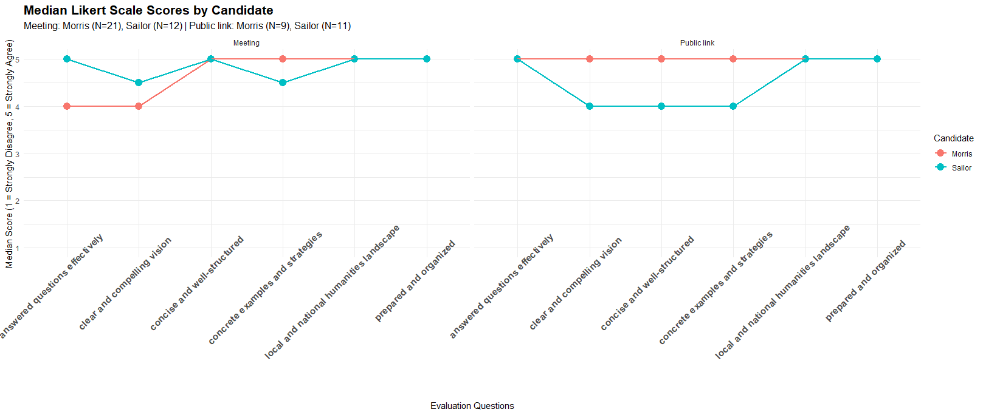

## Column M (Overall, I would rate this presentation as)

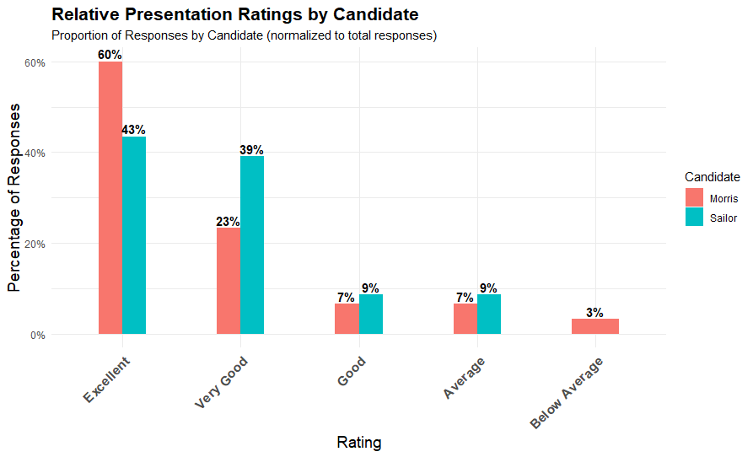

## Column Q (Would you recommend this candidate)

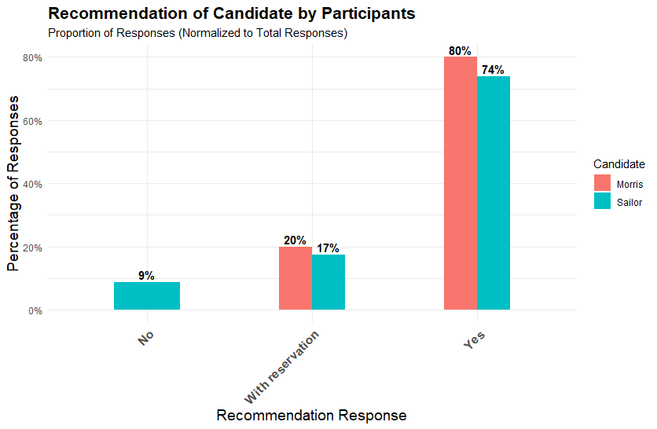

## Column N (What parts of this vision resonate with you and would best move WIHR forward? (please explain)

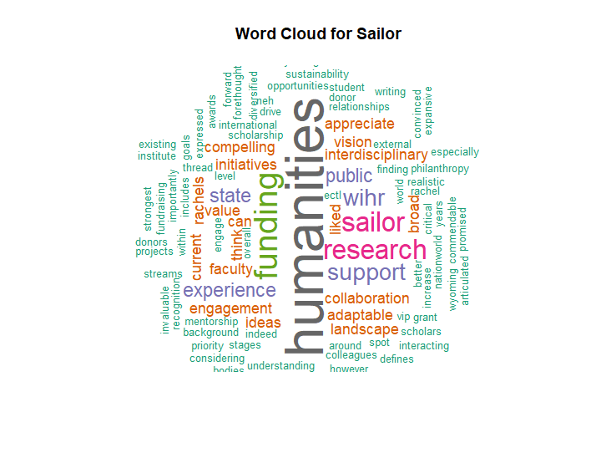

## Column O (What parts of this vision do you find unattainable or disagree with? (please explain)

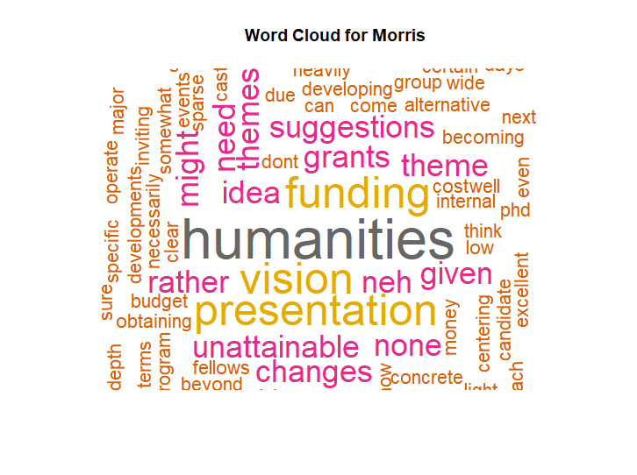

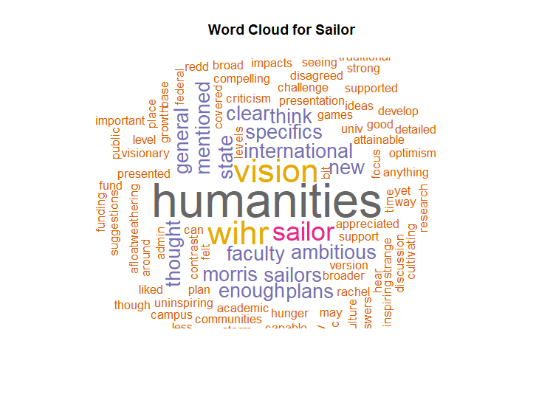

## Column P (Do you have any ideas about possible WIHR activities not covered in the talk but you would like to pass along?

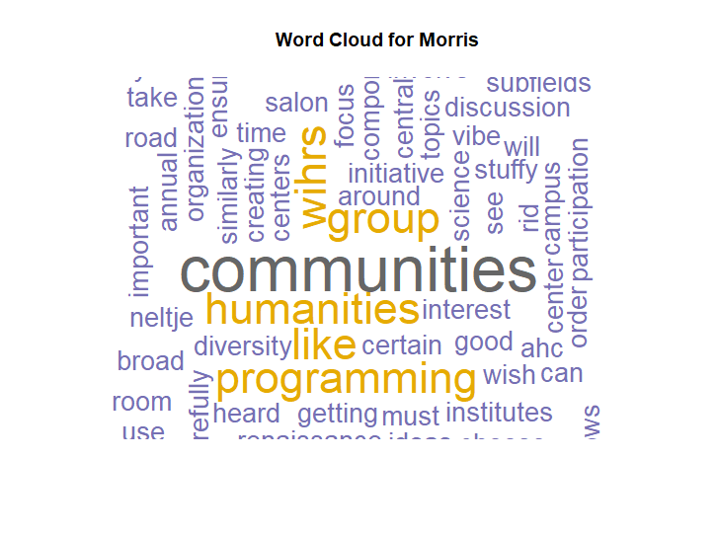

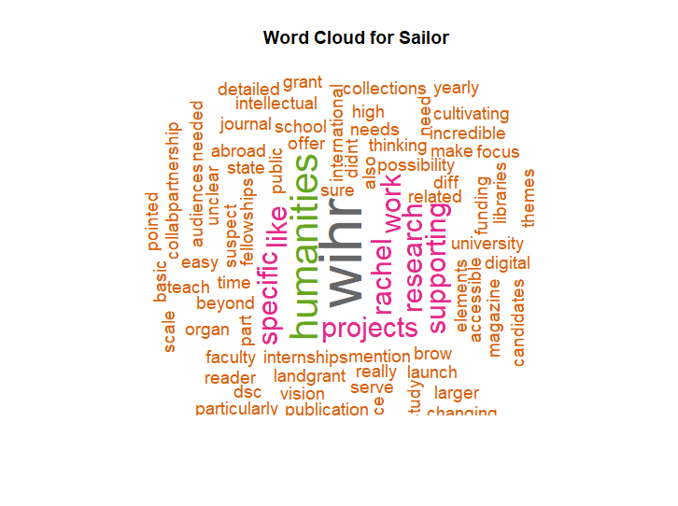

## Column S (Additional Comments)

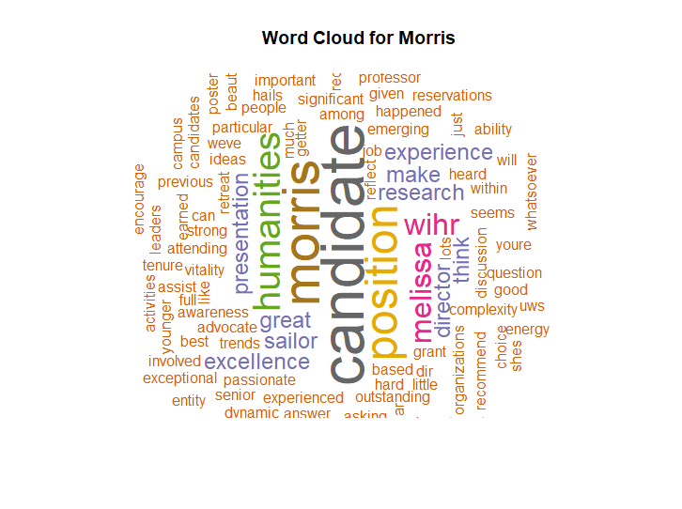

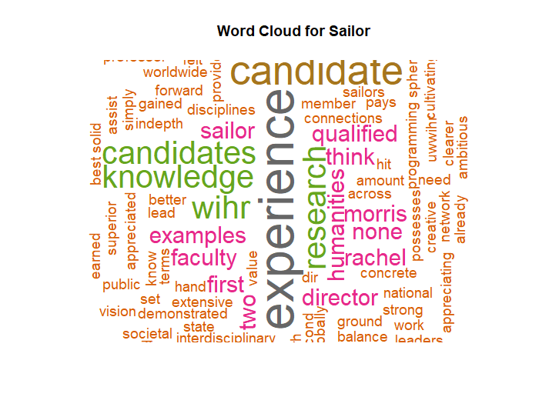

## 5. Summary

Based on the quantitative survey results, Morris consistently received higher median ratings across the key evaluation criteria compared to Sailor. A larger proportion of respondents rated Morris’s presentation as “Excellent” or “Very Good” and indicated they would recommend him without reservation. Overall, the data suggest that Morris was the more favorably evaluated candidate among survey participants.